From: https://emsnews.wordpress.com/2018/07/24/fisa-court-abuses-must-be-punished-arrest-comey-yates-rosenstein-and-mccabe/#more-37946
July 24, 2018 · 11:36 am

FISA Court Abuses Must Be Punished: Arrest Comey, Yates, Rosenstein And McCabe
(1) Hannity: FISA court was abused for political gain – YouTube

Hannity at Fox TV has a very good summary of the FISA court abuses engineered by Obama and Hillary. All the warrants against Trump’s staff were based on unverified or openly fake information fed to the court by a gang that hoped to rig the election so Hillary could win no matter what. Carter Page should sue all these clowns for defamation of character and an attempt to frame him based on false charges of treason. This attempt at framing a Trump ally was done so he would lie about Trump and Putin. But he refused to sing that song and now will hopefully see the gang who tried to frame him go to prison.

Rosenstein is in very deep water here. In the Hannity video, Rosenstein explains his own crimes…he actually tells us how this works and how people doing what he is doing is highly illegal! Only he pretends he isn’t doing what he condemns. Below is a screenshot of the John Hancocks of the criminal gang who tried to frame a President based on false ‘evidence’:
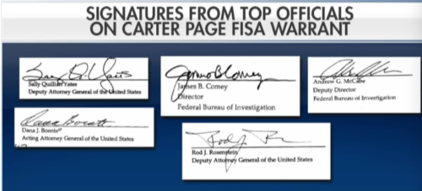
Yates, Comey, McCabe, Bonente and of course, Rosenstein himself are all on these documents used illegally to try to create a literal coup and take down the winner in an election. The mainstream media is mainly guilty, too, they pushed these false stories and lied about material information in order to whip up rage against a real President…all based on falsehoods!

This is a much bigger scandal than the Nixon scandals. Of course, war crimes are the very biggest but it seems almost all Presidents do that and Congress and the media push for war crimes, too.

This attempt at a coup should mean many people go to prison. Many should be kicked out of DC entirely and forever. The NY Times staff and owners should face charges, too. And the Washington Post’s billionaire owner of Amazon.com should be prosecuted.

We did this to the corporate/media giants in Nazi Germany at the Nüremberg Trials, after all.

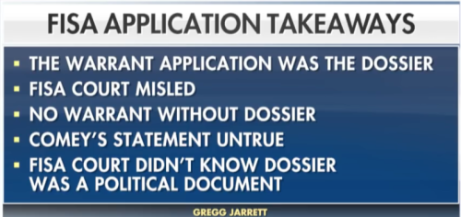
The lies in the media were used to get the FISA warrant to spy on Page. This circular conspiracy is very much fed by the owners of mainstream media.
Trump is removing the security clearances of the gang who tried so desperately to frame him. This abuse of power is obvious. The New York Times certainly is abusing its right to publish whatever it wishes. Every day, without exception, the lead story is anti-Trump no matter what really happens.

Today’s editorial spread is typical: all DNC/Bilderberg crimes are totally ignored or hidden or worse, made into Trump doing what they are doing like in this excellent example of twisted news today:
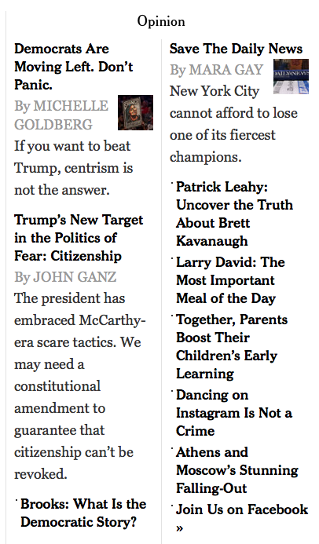
As the NYT embraces McCarthyism along with all the DNC, Ganz editorializes that TRUMP is doing this! The Jews running the NYT have a strong vested interest in dual citizenship. Back when this was introduced and passed along, I was very much against it. One cannot be a citizen of two places at once. This leads to treason eventually.

But they wanted it so they could control Palestine and now we have this snake in the grass in domestic politics.

[For the supportive material on related subjects not included here, see the above-referenced web page.]

